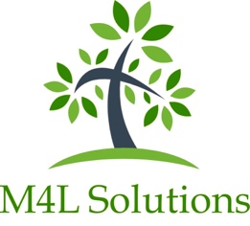

Delete Data Authorisation Form

In order to delete all data, please complete the authorisation form below required in order to process this request. The form must be completed by either a Senior Leader/Management or the Data Protection Officer.

Please note: once the form is returned and the data deleted you will not be able to recover any of your data.

Data deleted: All M4L Solutions internal records containing personally identifiable information.

Delete Data Form

I fully understand that by signing and returning this form M4L Solutions will delete all of our organisation’s PII stored on their internal systems.
I confirm that I am authorised to process this request.

Organisation name:
Postcode:
Phone number of school:
Your name:
Job Title:
Signature:

